PA B3-1: ALCUIN
TOPIC
B3
STUDENT OOP
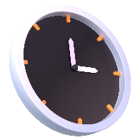
TIME TO COMPLETE: 1 HOUR

MAX MARKS: 42
We’ll be creating a class to represent your typical Alcuin student.
- Identify what variables/attributes you’d like to keep track of for the student. At least one of these variables should be a list of other variables. There should be at least 3 variables. [4]

- Identify what functions this student class should have to operate on the variables. Each variable should interact with at least one function. Be sure to include a constructor and a ToString. [8]

- Fill in this UML diagram with the data from the questions above [10]
ClassTitle:
Variables:
Functions:

- Implement this UML diagram as a class in a Python script that you attach alongside this document with an upload. [10]

- Using the class you’ve created, make a program that initializes multiple students in a list and prints them out to the screen using the ToString method. Before you print them, use each function to modify at least one of the objects to prove that they work. [10]

